[](http://www.clker.com/clipart-9220.html)**Social Studies 10: Current Events**

In the current millennium, our world is truly a global village and since you are a responsible global citizen, you feel the need to keep informed about the world around you. To that end, you will be researching **current events** and reporting on those happenings.

You will be preparing five individual **“scrapbooks”** which will have, on individual pages, the article, the article summary, and your personal reflection on the significance of the issue.

1. You must gather **five articles**
2. All articles must deal with **various current issues.**
3. As we know, there are 4 different types of current events. Local, Provincial, National and International/global. You must have at least THREE different types of current events. The last two can be of your choice. When writing the summary, you must state what type of current event it is.
4. All articles must be green-lighted by Mr. Lepage as soon as possible. **Note:** This must be done prior to handing in each scrapbook (at the latest, the day before) or you will receive a zero.
5. Article 1: ______________________________ Due: February 20, 2014
6. Article 2: ______________________________ Due: March 20, 2014
7. Article 3: ______________________________ Due: April 21, 2014
8. Article 4: ______________________________ Due: May 20, 2014
9. Article 5: ______________________________ Due: June 3, 2014

1. The **summary** should be typed and a half to full page in length. Summarize the article according to the 5 Ws (Who, What, Where, When, Why). **Please be sure to write the date, source, and title of the article at the beginning.**
2. You will also be required to explain the (**global)** **significance of the article**. This can be done by outlining some common reactions to the issue. You can also look at the consequences or benefits of the issue. Basically, you are answering the questions: Why should the world/city/Province/Country rejoice/be concerned about this article? What are the global/city/Province/Country rejoice implications? **Please note:** This should be done as a separate paragraph from the summary and must also be typed.

Sources can include, but are not restricted to newspapers, magazines, and the internet.

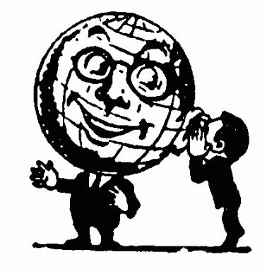

**Current Events Scrapbook Evaluation**

**Each selection will be mark under the following criteria:**

Article must be present /1

Summary /4

* Typed
* Length
* 5Ws
* Important parts are kept
* Title, source, and date

Significance /5

* Paragraph form
* Six or more sentences
* Typed
* Content- did you explain the significance?

**Total /10 for each selection**

**Grand Total /50**

**Please note:** This assignment is worth ten percent of your final mark!!!

**Also note:** This outline must be handed in with each scrapbook or you will receive a zero!!!